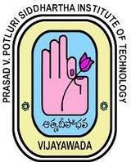 | Prasad V Potluri Siddhartha Institute of Technology  (Autonomous) Kanuru-Vijayawada-520007  Department Of Computer Science & Engineering (AI&ML)

Date: 19-03-2025

Academic Year: 2024-2025 Class: III B. Tech CSE (AI&ML)

S. No | Name of the Certification  Course | Organized by | Dates | No. of participants
1. | Python 3.4.3 | Spoken-Tutorial | 20-07-2024 | 68
2. | Introduction To Machine Learning | Swayam NPTEL | 22-09-2024 | 47
3. | Programming in Java | Swayam NPTEL | 27-10-2024 | 41
4. | Design and Analysis of Algorithms | Swayam NPTEL | 27-10-2024 | 11
5. | Linux | Spoken-Tutorial | 21-02-2025 | 57

